Insertion sort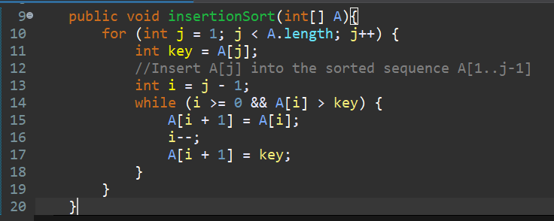

2.1-2

Merge and MergeSort

2.3-5

2.2

